FT-IWHR user manual

Check dams are built in groups, spreading in several tributaries in cascade forms, comprising a complex network. Due to their less stringent flood control standards compared to other dams, check dams are more vulnerable to failure. The FT-IWHR program aims to determine the critical precipitation that will result in overtopping of a dam, which is a useful approach to assessing the risk of failure on a probabilistic basis and for providing early warning in case of an emergency. This program is coded on Microsoft (MS) Excel spreadsheets supported by Visual Basic for Applications (VBA) programming, based on the approach proposed by the authors (Zuyu, Chen., Xieping, Huang., Shu, Yu., Wei, Cao., Weiqin, Dang., & Yangqiang, Wang. (2020). Risk analysis for clustered check dams due to heavy rainfall. International Journal of Sediment Research).

This approach decompose the dam cluster into (1) the heading dam, (2) border dams, and (3) intermediate dams. The algorithm begins with the border dams that have no upstream dams and proceeds with upgraded maps without the previous border dams until all the dams have been checked. This approach successfully investigates the Wangmaogou Check Dam System consisting of 22 reservoirs based on a precipitation database covering 1964-2010. More details should be found in the reference mentioned above.

The initial interface of this program is the information input interface with a worksheet named ‘InformationInput’, as shown in Fig. 1. Six system parameters and a total of 12 parameters of each check dam are need to input by users. The meanings and the units of these parameters are presented in top right of the ‘InformationInput’ worksheet, as shown in Fig. 1. More details about these parameters should be found in the paper referenced above.

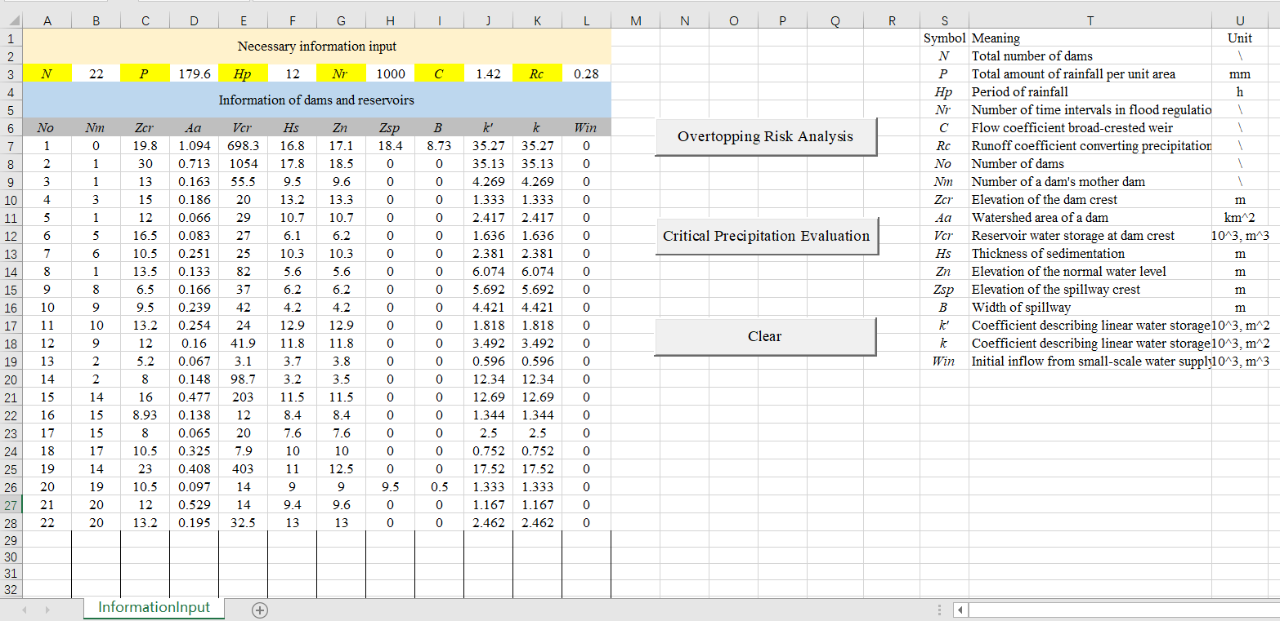

Fig. 1 Information input interface of the FT-IWHR program

There are two key functions of the FT-IWHR program. Function one, associated with user button ‘Overtopping Risk Analysis’, is to analyze the check dam failures due to overtopping for a given storm intensity (duration and rainfall). Function two, associated with user button ‘Critical Precipitation Evaluation’, is to assess the critical precipitation that will result in overtopping of each check dam. By running Function one, one may obtain the overtopped and survived check dams for a given storm intensity. By running Function two, one may obtain the critical precipitation of each check exceeding which the dam will be overtopped.

After input all the need information, click user button ‘Overtopping Risk Analysis’ to activate the function one. Then, four extra worksheets will be generated automatically to record the calculation process. The four extra worksheets are named as ‘InputDataCheck’, ‘CalculationProcess’, ‘Spillway’ and ‘Summary’.

‘InputDataCheck’ worksheet is to write out all the input information and check there is no error. This is important for a complex check dam system with a number of check dams.

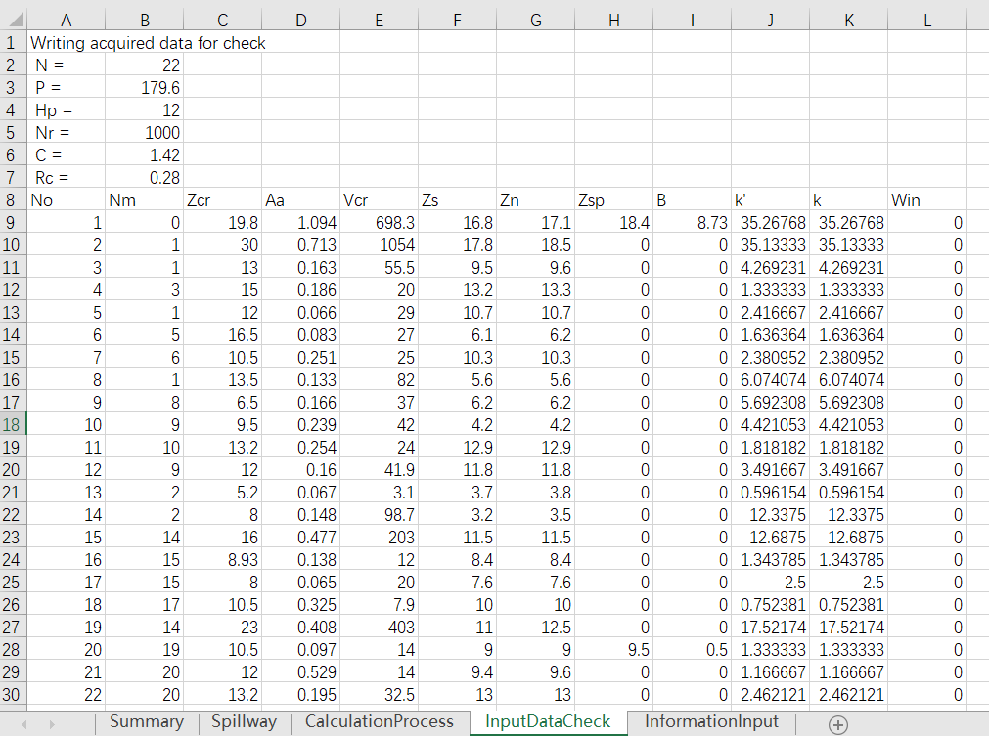

Fig. 2 ‘InputDataCheck’ worksheet

‘CalculationProcess’ worksheet is to record the identified bord dams and the upgraded map of the check dam system of each loop.

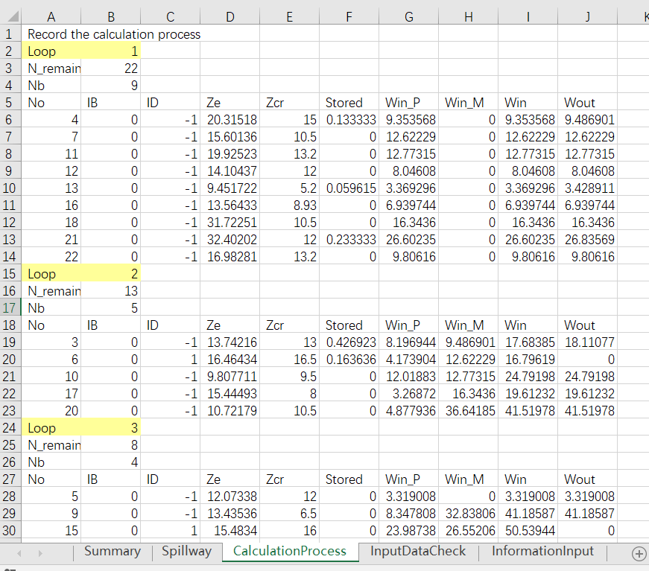

Fig. 3 ‘CalculationProcess’ worksheet

‘Spillway’ worksheet is to record the flood regulation of the check dam with a spillway.

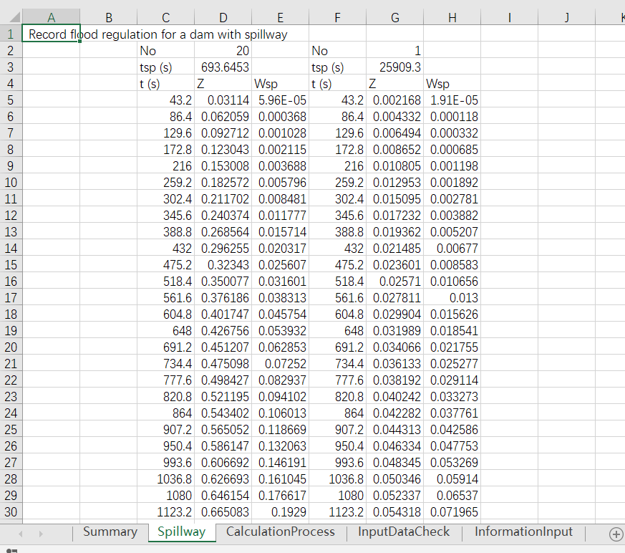

Fig. 4 ‘Spillway’ worksheet

‘Summary’ worksheet is to summary the overtopped and survived check dam.

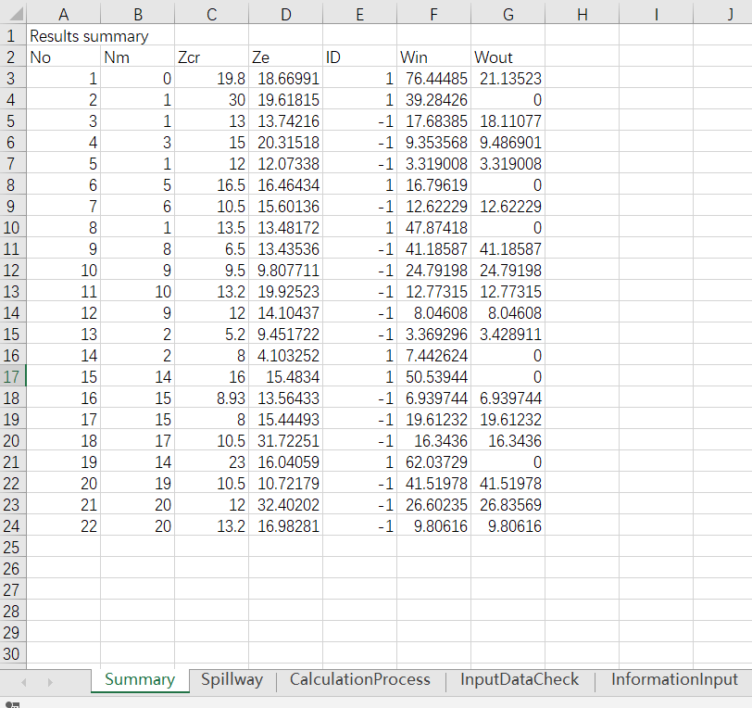

Fig. 5 ‘Summary’ worksheet

Click user button ‘Clear’ in the information input interface, the four generated worksheets will be deleted.

Attention: do not rename the ‘InformationInput’ worksheet.